C:\Users\Keith\AppData\Local\Temp\SNAGHTML70fed58.PNG

**Sample Car Application**

TECHNICAL REQUIREMENTS

Version 1.0  
February 14, 2022

**Abstract**

The solution for the Sample Car Application of the proposed process automation provides the timely reduction of excess process that is standard across BIDs Group, Commercial to all plants using an automated workflow process.

|  |  |  |  |
| --- | --- | --- | --- |
| Date | Version | Changed By | Changes |
| February 14, 2022 | Version 0.1 | Maryna Nikolaienko | Original Version. |
|  |  |  |  |

Table of Contents

Overview 4

Business Case 4

Functional Description 4

Forms 5

Data Used for Application Lookup and Process Control 5

Stored Procedure 5

Data Access (K2 SmartObjects) 6

General Notes 7

Workflow Activities 7

Sample Car 7

Workflow K2 Implementation 8

Process Details 9

Forms and Reports (K2 SmartForms) 13

Admin form - SCAdmin.Form 13

Sample Car – Landing Form - SCRequest.LandingForm 17

Sample Car Request Form - SCRequest.Form 19

Worklist form - SCWorlist.Form 24

Sample Care Project and Reporting Data (Custom SQL Server Database) 25

DB Schema with Relations 26

Filtering 27

# Overview

This article presents the technical requirements for the Automated Sample Car process using the K2 blackpearl User Manager, K2 OOB AD Service Brokers application platform for user authentication (Active Directory). User authorization is implemented using the Active Directory groups and the SQL Server application database tables and logic.

# Business Case

The Sample Car Process is implemented using a combination of the following technologies:

* SQL Server application database
* K2 blackpearl service brokers
* K2 SmartObjects
* K2 blackpearl workflow process definitions
* K2 SmartForms

## **Functional Description**

Business Process

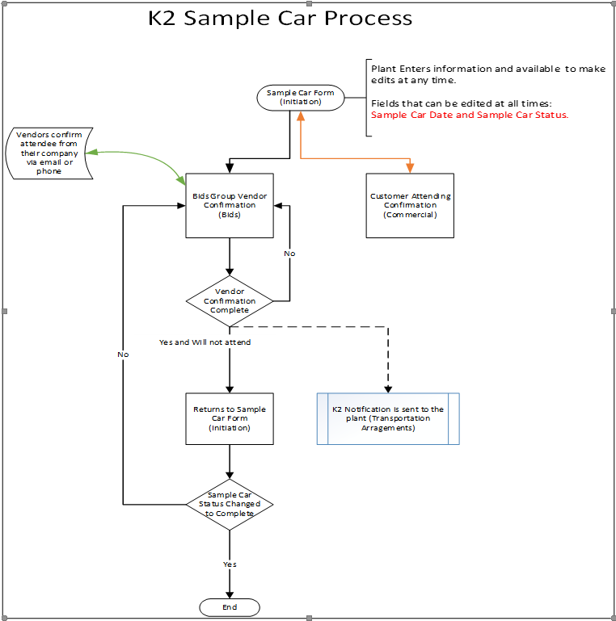

## **Forms**

* *SCAdmin.Forms*

Form for administering data values for the Sample Car process

* *SCRequest.LandingForm*

This form allows you to see all existing requests for a Sample Car process.

* *SCRequest.Form*

This form allows you to manage Sample Car requests.

* *SCWorlist.Form*

Displays existing tasks after the process starts

## **Data used for application lookup and process control**

* Application Process Form Data Model
* SCAdmin
* SCAttachments
* SCEmailSent
* SCRequest
* SCSampleCarEmailNotify
* SCTaskHistory
* SCVendorConfirmation
* SCVendorInfo
* User Role Data Model
* SCUsers

## **Stored Procedure**

dbo.SP.SampleCarGetId

dbo.SP.SCCreateVendorConfirmation

dbo.SP.SCEmailBody

dbo.SP.SCExcelExport

dbo.SP.SCGetCommodities

dbo.SP.SCGetContact

dbo.SP.SCGetEmailAddresses

dbo.SP.SCGetPlantsForUser

dbo.SP.SCGetSentEmailVendorBody

dbo.SP.SCGetUsers

dbo.SP.SCGetVendorContact

dbo.SP.SCGetVendorsNumber

dbo.SP.SCLanding

dbo.SP.SCSentEmailSubject

dbo.SP.SCValidateVendConf

dbo.SP.SCVendorConfEmailBody

dbo.SP.SCVendorEmail

dbo.SP.SplitPlant

## **Data access (K2 SmartObjects)**

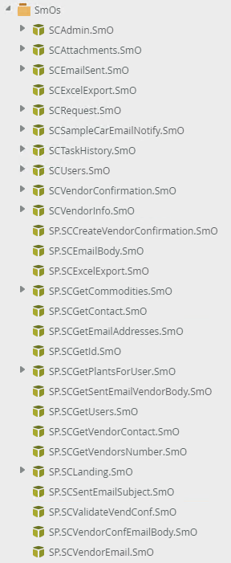

Workflow Processes

## General Notes

1. The workflow task and email actions will be configured using the SCAdmin.Form.

2. The target user of the workflow task action is the roles located in the Commercial, Bid Group tab and Plant of the Sample Car Admin Form.

3. The Task Activity form is the Sample Car Initiation Form.

4. The workflow email action email is a pre-configured email selected from the BIDs Group Notification, Commercial, Email Notification, Plant POC, and Bid POC tabs of the Sample Car Admin form.

## Workflow Activities

The steps on the workflow process are called Activities. Activities should allow the system to perform work or to assign work to be performed by one or more destination users.

## Sample Car

This process creates a request with a generated Sample Car Application

|  |  |
| --- | --- |
| Who owns this process? | Originator |
| How does the process start? | The end-user will submit a Sample Car Initiation Form. |
| How often does the process start? | As needed |
| Who or what initiates the workflow? | Originator |
| When does the workflow end? | After Email Notification on the groups and originator of users about the finishing process |

## 

## Workflow K2 Implementation

*K2 blackpearl Workflow Processes*

* **Automated Sample Car process**

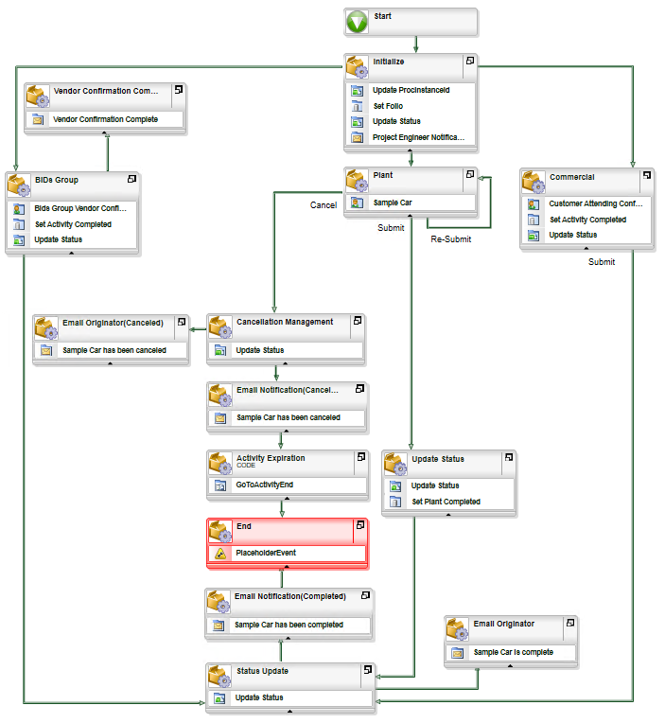

## Process Details

1. *Start*

The plant enters the Sample Car Request form and then Submit. The Sample Car Process starts when the form is submitted.

1. *Initialize*

The Workflow Process variables are initialized, the process instance folio is set and the process instance ID is saved to the application database.

• Who or what performs the tasks in this phase?

* System

• What tasks are carried out at this stage?

* Update ProcInstanceId
* Set Folio
* Update Status Pending BIDs Group, Plant, Commercial
* Send e-mail Notifications

• Why is this step necessary?

* In order to initiate a Sample Car Information Request

*3.1 BID’s Group*

BID’s Group will add vendor confirmation and email to vendor as needed, after finishing the task form and submitting it to finish the process.

• Who or what performs the tasks in this step?

* Bids Group

• What tasks are performed in this step?

* BIDs Group Notification Email
* Set Activity Completed
* Update Status

• Why is this step necessary?

* Bids Group Vendor Confirmation

• What is the result of this step?

* Submit, *Send Email (Vendor Email Notification workflow will be launched)

*3.1.1 Vendor Confirmation Complete*

* Who or what performs the tasks in this step?
  + System
* What tasks are performed in this step?
  + Send email
  + Why is this step necessary?
  + An email will be sent to the Originator and the Vendor Group Vendor Attending Confirmation
  1. *Commercial*

Commercial will complete the commercial task form and submit

* + Who or what performs the tasks in this step?
  + Commercial

• What tasks are performed in this step?

* Commercial Sample Car Notification Email
* Set Activity Completed
* Update Status

• Why is this step necessary?

* Customer Attending Confirmation

• What is the result of this step?

* Submit
  1. *Plant*

Plant will update the status and date and submit. If the status is complete or cancelled to finish the process.

• Who or what performs the tasks in this step?

* Plant

• What tasks are performed in this step?

* Select action, update date

• Why is this step necessary?

* Update Status for finishing the process.

• What is the result of this step?

* Submit, Re-Submit, Cancel

*3.3.1 Update Status*

• Who or what performs the tasks in this step?

* Plant

• What tasks are performed in this step?

* Set Activity Completed
* Update Status

• Why is this step necessary?

* Set Plant Completed

*3.3.2 Cancellation Management*

* Who or what performs the tasks in this step?
  + System
* What tasks are performed in this step?
  + Update Status
  + Why is this step necessary?
  + Update Status Canceled

*3.3.2.1 Email Originator (Canceled)*

* Who or what performs the tasks in this step?
  + System
* What tasks are performed in this step?
  + Send email
  + Why is this step necessary?
  + An email will be sent to the Originator that the Sample Car has been canceled.

*3.3.3 Email Notification (Canceled)*

* Who or what performs the tasks in this step?
  + System
* What tasks are performed in this step?
  + Send email
  + Why is this step necessary?
  + An email will be sent to the users in the email notifications tab that the Sample Car has been canceled

*3.3.4 Activity Expiration*

* Who or what performs the tasks in this step?
  + System
* What tasks are performed in this step?
  + GoToActivityEnd (Step 6. End)

1. *Status Update*

* Who or what performs the tasks in this step?
  + System
* What tasks are performed in this step?
  + Update Status
  + Why is this step necessary?
  + Update Status Completed

*4.1 Email Originator*

* Who or what performs the tasks in this step?
  + System
* What tasks are performed in this step?
  + Send email
  + Why is this step necessary?
  + An email will be sent to the Originator that the Sample Car has been completed.

1. *Email Notification (Completed)*

* Who or what performs the tasks in this step?
  + System
* What tasks are performed in this step?
  + Update Status
  + Why is this step necessary?
  + After the Sample car is completed, an email will be sent to the originator and users in the email notifications tab.

1. *End*

After three tasks are completed then End Process. The workflow process instance is completed.

* Who or what performs the tasks in this step?

##### System

* What tasks are performed in this step?
  + Set status and add a record to the request history.
* Why is this step necessary?
  + Finishing the process.
* **Vendor Email Notification**

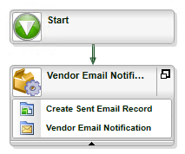

1. *Start*

The Vendor Email Notification process starts after clicking the Send Email button on the SCRequest.Form of the BID's Group step.

1. *Vendor Email Notification*

• Who or what performs the tasks in this phase?

* System

• What tasks are carried out at this stage?

* Create Sent Email Record
* Vendor Email Notification

• Why is this step necessary?

* This is an information letter displaying the persons responsible for certain information.

# Forms and Reports (K2 SmartForms)

## **Admin form - SCAdmin.Form**

* *Vendors’ List*

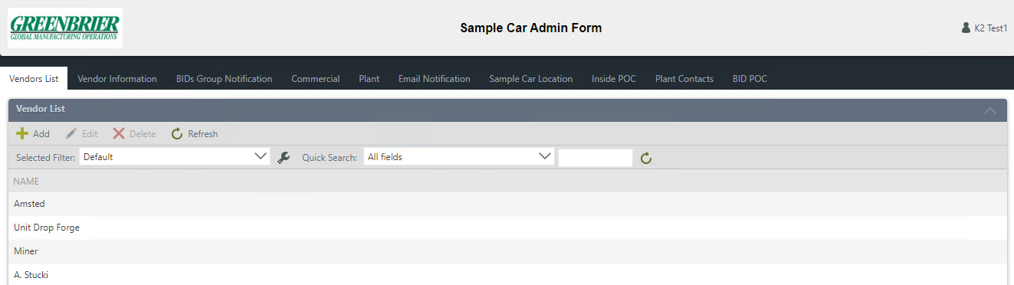



- The *Add* button is for adding a Vendor.

- The *Edit* button allows you to edit the **Name.**

- The *Delete* button allows you to delete the selected entry.

- The *Refresh* button refreshes the current page.

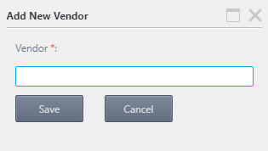

By clicking the "*Add*" button on the toolbar, a pop-up form will open to Add a New Vendor.

* *Vendor Information*

The "BIDs Group" task will contain a "Vendor Presence Confirmation" section, in which you can add suppliers located on this tab.

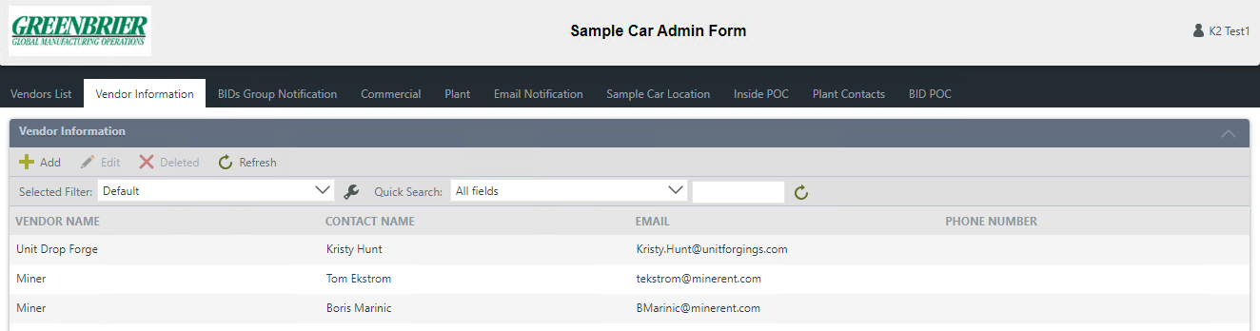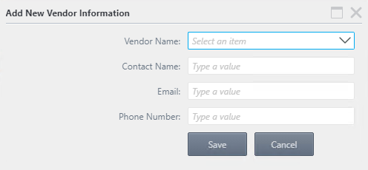



- The *Add* button is for adding Vendor Information.

- The *Edit* button allows you to edit the Vendor Information.

- The *Delete* button allows you to delete the selected entry.

- The *Refresh* button refreshes the current page.

By clicking the "*Add*" button on the toolbar, a pop-up form will open to Add New Vendor Information

After selecting the *Vendor name* from the drop-down list, you need to fill in all the fields of the pop-up form.

* *BIDs Group Notification, Commercial, Plant*

On BIDs Group Notification, Commercial, Plant tabs, you can configure the recipients of the task and, accordingly, the emails about the received task for each of the Plants.

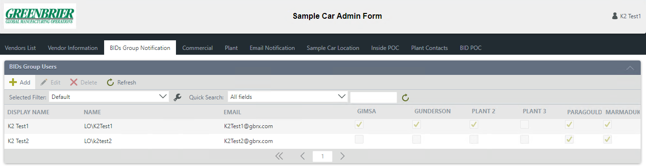



- The *Add* button is for adding a New User.

- The *Edit* button allows you to edit the User.

- The *Delete* button allows you to delete the selected entry.

- The *Refresh* button refreshes the current page.

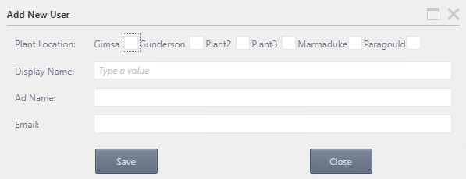

By clicking the "*Add*" button on the toolbar, a pop-up form will open to Add a New User. Here you can set from which plants the tasks for the specified user will come, in accordance with the set checkboxes.

* *Email Notification*

After the Sample Car process is completed, an e-mail about it will send to the Originator and users on the Email Notification tab.

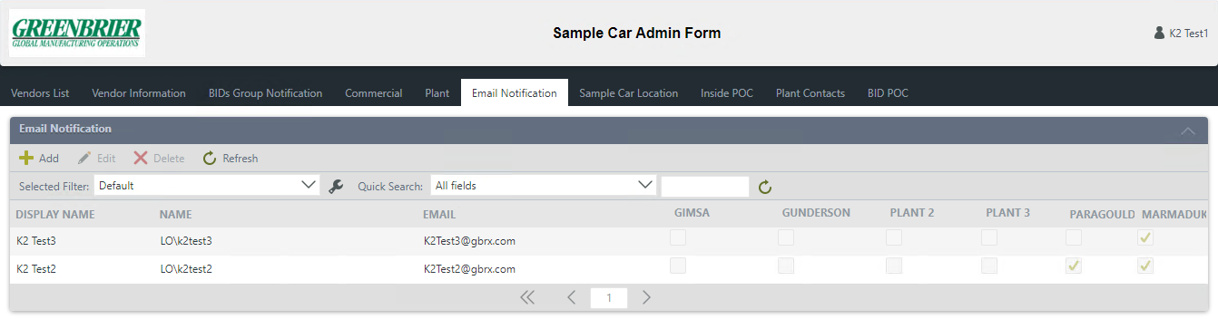



- The *Add* button is for adding a New User.

- The *Edit* button allows you to edit the User.

- The *Delete* button allows you to delete the selected entry.

- The *Refresh* button refreshes the current page.



By clicking the "*Add*" button on the toolbar, a pop-up form will open to Add a New User. Here you can specify, after the completion of the Sample Car process, from which plant’s emails will be sent to the specified user, in accordance with the selected checkboxes.

* *Sample Car Location*

The data from this tab will be displayed in the Sample Car Location dropdown list in the Request view.

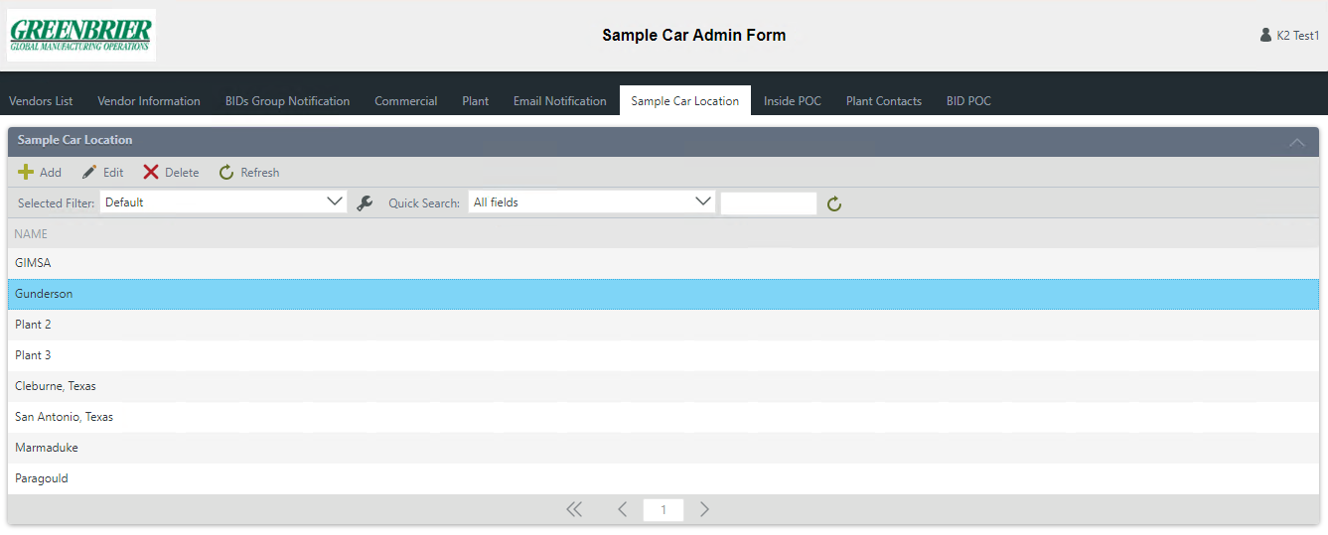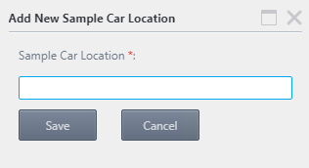

By clicking the "*Add*" button on the toolbar, a pop-up form will open to Add a New Sample Car Location.



- The *Add* button is for adding a New User.

- The *Edit* button allows you to edit the User.

- The *Delete* button allows you to delete the selected entry.

- The *Refresh* button refreshes the current page.

* *Inside POC*

The data from this tab will be displayed in the Inside POC (point of contact) dropdown list in the Request view.

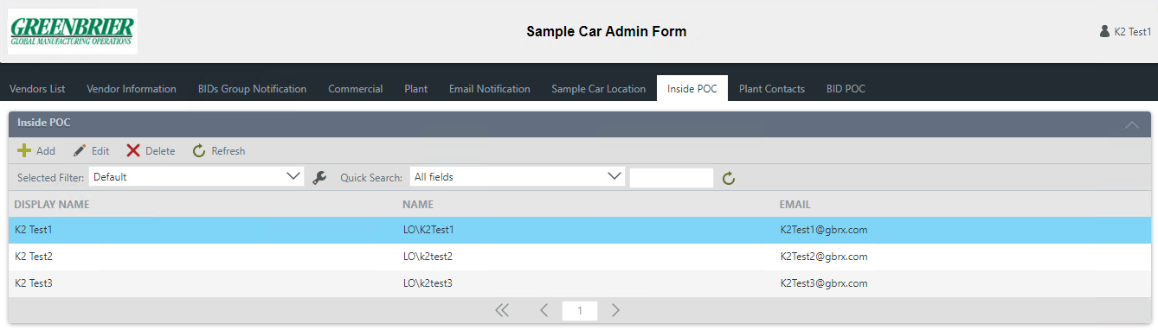



- The *Add* button is for adding a Display Name.

- The *Edit* button allows you to edit the Display Name.

- The *Delete* button allows you to delete the selected entry.

- The *Refresh* button refreshes the current page.

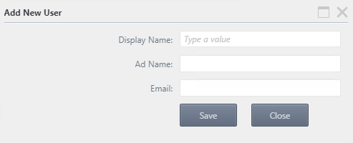

By clicking the "*Add*" button on the toolbar, a pop-up form will open to Add New User.

* *Plant Contacts*

This tab contains Usernames and their emails, whose names will be displayed in the body of the emails. For example: Originator Notification (Completed), Vendor Notification (from the task form) and Project Engineer Notification.

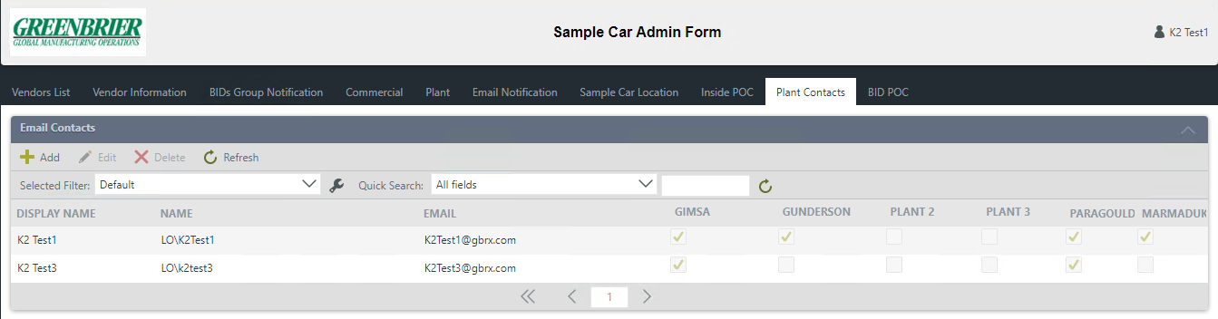



- The *Add* button is for adding a Display Name.

- The *Edit* button allows you to edit the Display Name.

- The *Delete* button allows you to delete the selected entry.

- The *Refresh* button refreshes the current page.

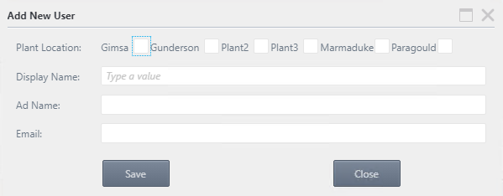

By clicking the "*Add*" button on the toolbar, a pop-up form will open to Add a New User. Here you can specify the users who will be listed in the body of the email, according to the particular plant by checking the boxes.

* *BID POC*

This tab contains the names of the purchasing contact person, which depends on the selected plant. Their names will be displayed in the body of the email’s Vendor Notification (from the task form).

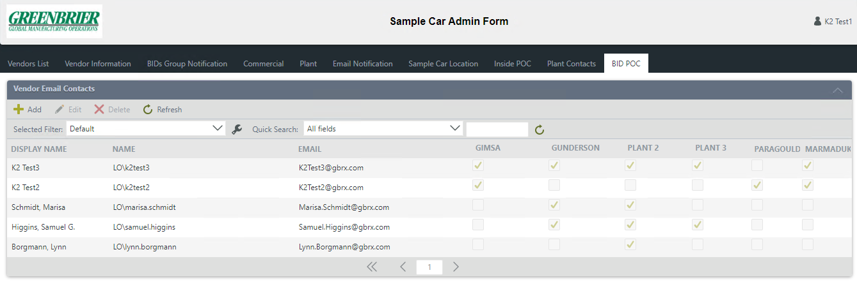



- The *Add* button is for adding a Display Name.

- The *Edit* button allows you to edit the Display Name.

- The *Delete* button allows you to delete the selected entry.

- The *Refresh* button refreshes the current page.



By clicking the "*Add*" button on the toolbar, a pop-up form will open to Add a New User. Here you can specify the users who will be listed in the body of the email, according to the particular plant by checking the boxes.

## **Sample Car – Landing Form - SCRequest.LandingForm**

For the data on SCRequest.LandingForm - there are no restrictions on roles. Everyone has access to the New tab. There is only data filtering. Users in the Admin from the BIDs Group and Plant tabs can see those records to which plants they have access (that is, there is a checkmark for this plant in the Admin.). Users from the Commercial tab see all entries.

* Landing form – New tab

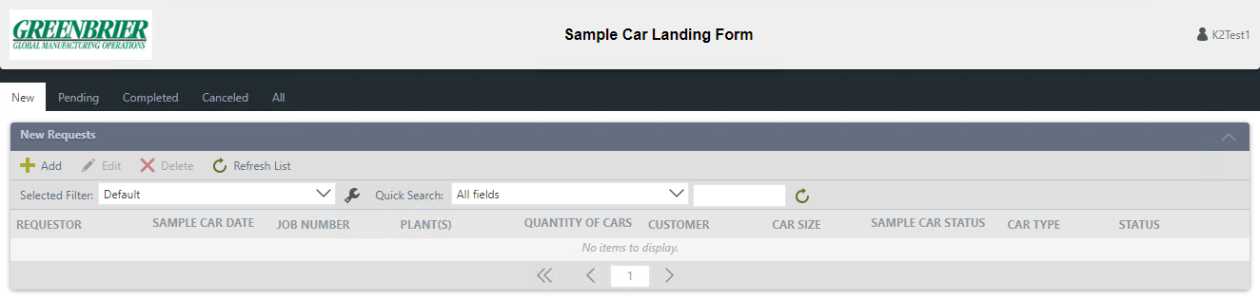

The Allocated User is displayed here.

Users can use different filtering and quickly search for the request that they are interested in.

Tabs are organized to create a new request, as well as display the status of the request on the corresponding tab.



- The *Add* button opens the request form.

- The *Edit* button allows you to change the created request.

- The *Delete* button allows you to delete the selected query.

- The *Refresh* button refreshes the current page.

Workspace where requests for work are located

* Landing form – Sample Car Pending, Completed, Canceled tabs

After the Request form is closed, the current request will be displayed in the appropriate tab, according to the status of the process.

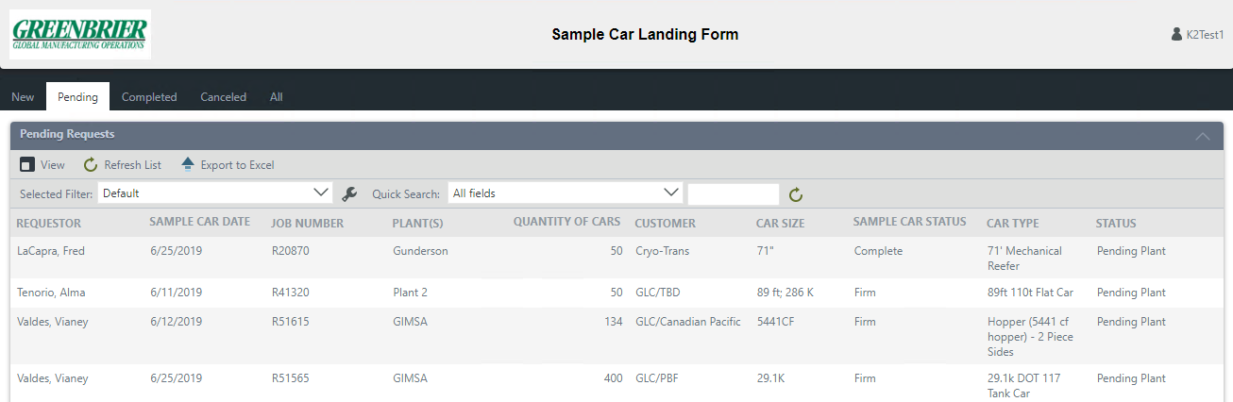

Saved requests are arranged according to the corresponding tab, according to the process status



- The *View* button opens the request form for viewing.

- The *Export to Excel* button allows you to unload all the information on the sheet.

- The *Refresh* button refreshes the current page.

* Landing form – Sample Car All tab

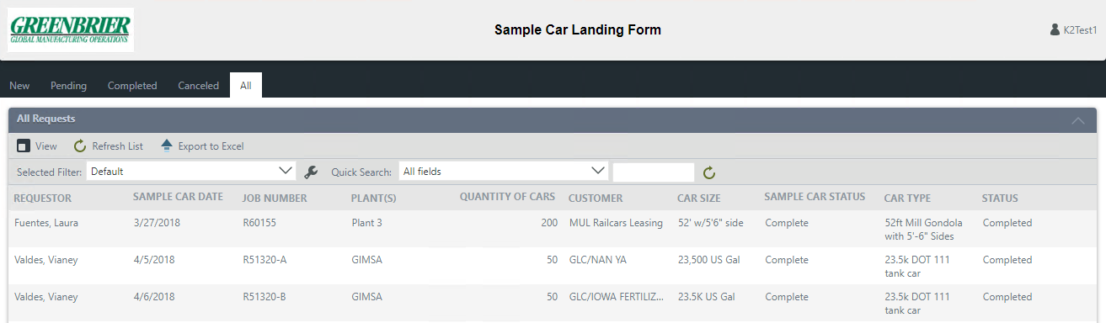

The *All* tab contains all created requests for all plants

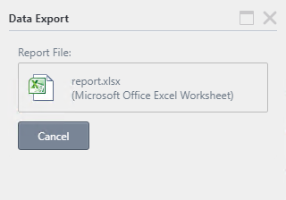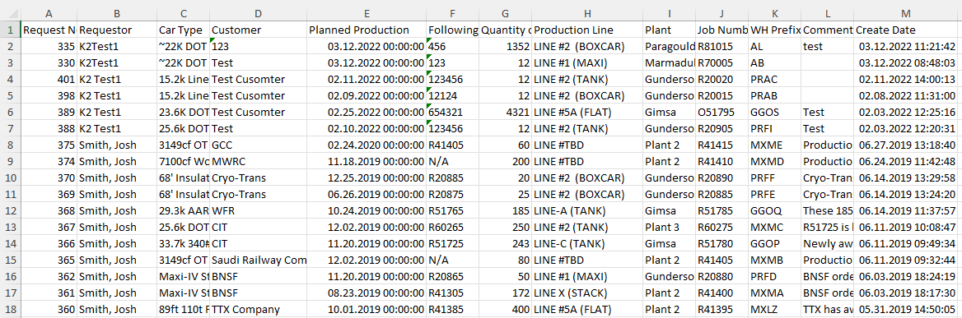

If necessary, export data to Excel:

1. Click on the *Export to Excel* button.

2. The Data Export window will appear, in which the file will be generated. Click on it to download it to your PC.

3. Then close the Data Export window

## **Sample Car Request Form - SCRequest.Form**

SCRequest.Form - there are no restrictions on access to roles, but the Plant(s) drop-down list on the form is filled only with those plants that the user has access to in the Admin. panel on the Plant tab. Since this field is required and will only be relevant for users from the Plant tab, it turns out that only they can start the process.

* *Sample Car Initiation Form*

To initialize the Sample Car form, you must fill in all the fields of the form.

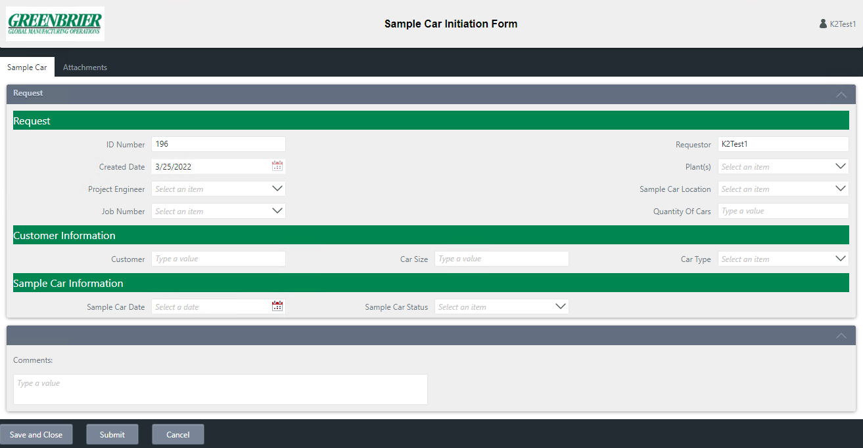

- Clicking the *Save and Close* button creates a Draft for the Sample Car request.

- Pressing the *Submit* button starts the process and saves it.

- Clicking the *Cancel* button closes the open form.

After selecting the Plants value, the Job Number values will become available. After the value Job Number is selected, the fields Quantity Of Cars, Customer, Car Type will be automatically filled.

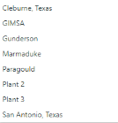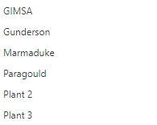

***\*Note***

Added Marmaduke and Paragould to “Plant(s)” drop-down list

Added Marmaduke and Paragould to “Sample Car Location” drop-down list

The Project Engineer dropdown is populated from the BidAdmin.Form of the Engineer tab.

The " Sample Car Initiation Form" form contains two tabs: "Sample Car" and "Attachments". On the "Attachments" tab, the user has the opportunity to attach the necessary file to the current Request, give the file a name and leave a comment on the file.

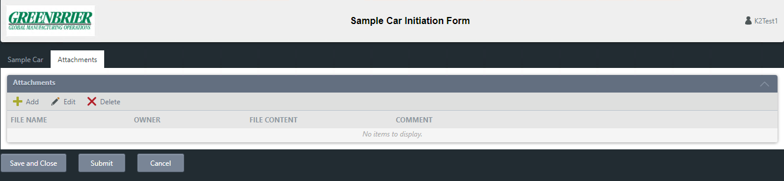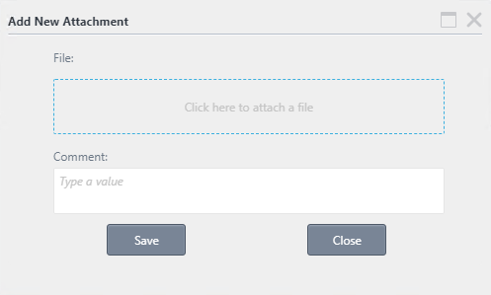

To attach a file, go to the "Attachment" tab.

- The *Add* button will open a pop-up window to upload a file.

- The *Edit* button allows you to edit the added comment and upload another file.

- The *Delete* button allows you to delete the selected entry.

By clicking on the *Add* button, a window for attaching a file will open.

Once the Sample Car Information Form has been submitted, emails will be sent to the Project Engineer, as well as anyone marked on the BIDs Group and Commercial tabs as the executor for the selected Plant on the form.

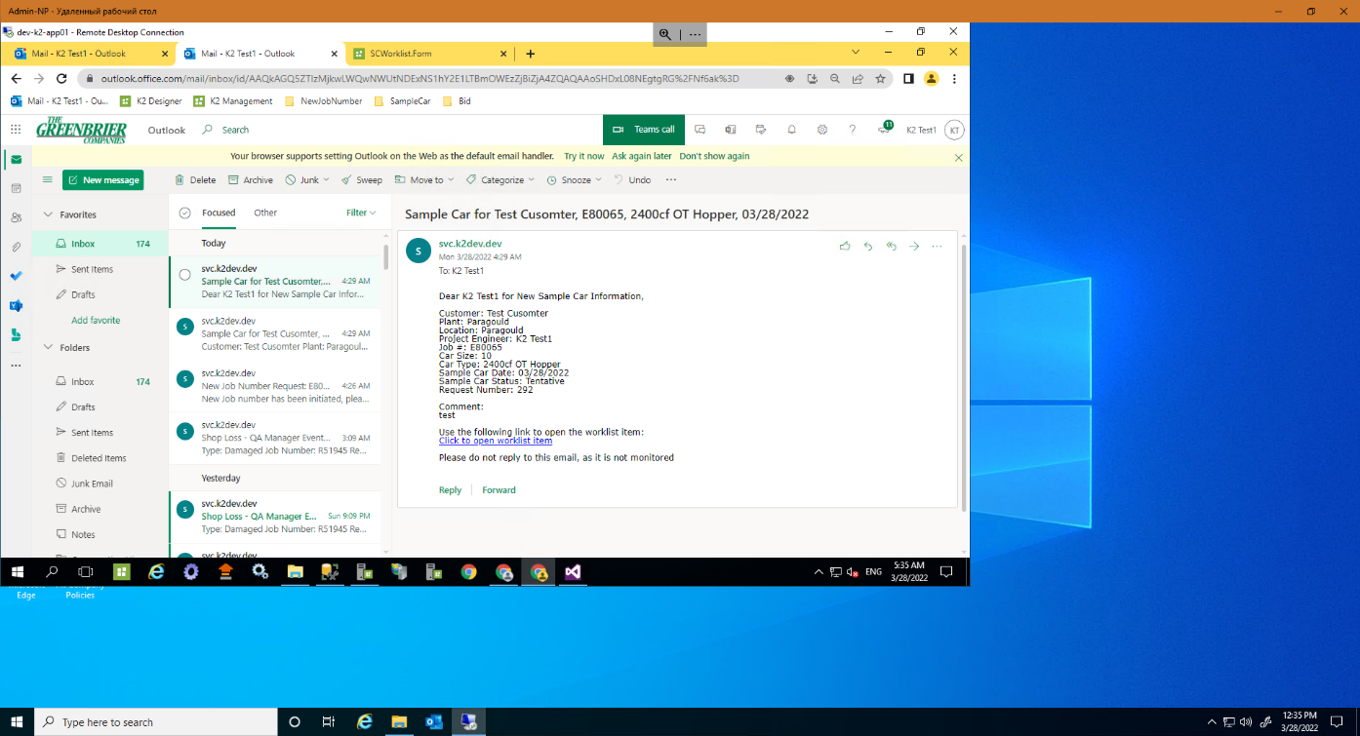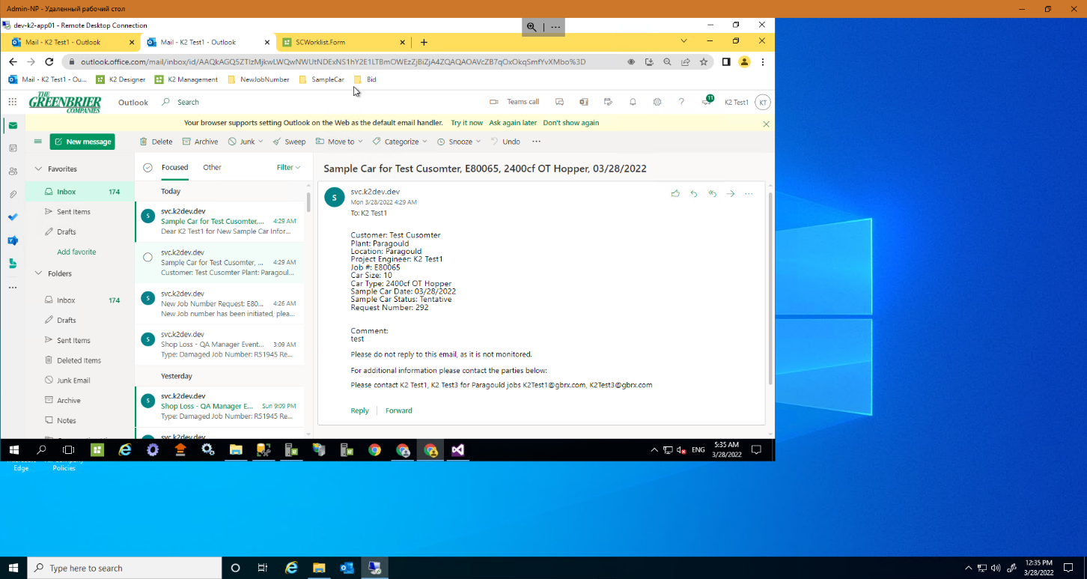

* *Plant*

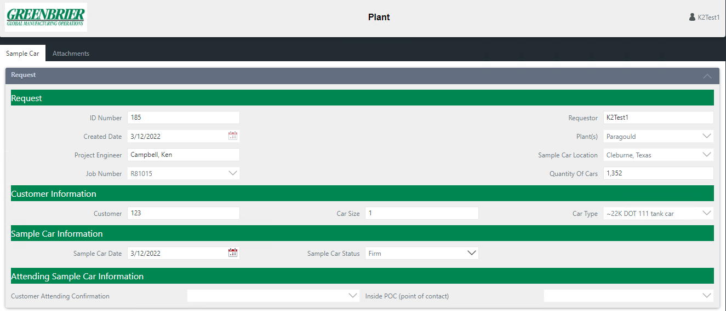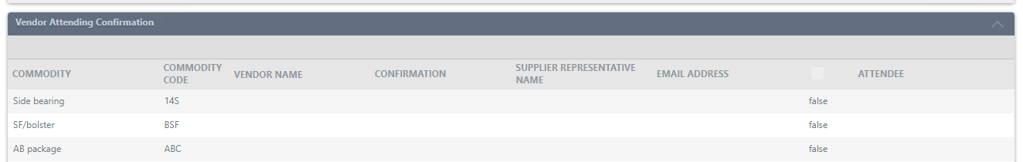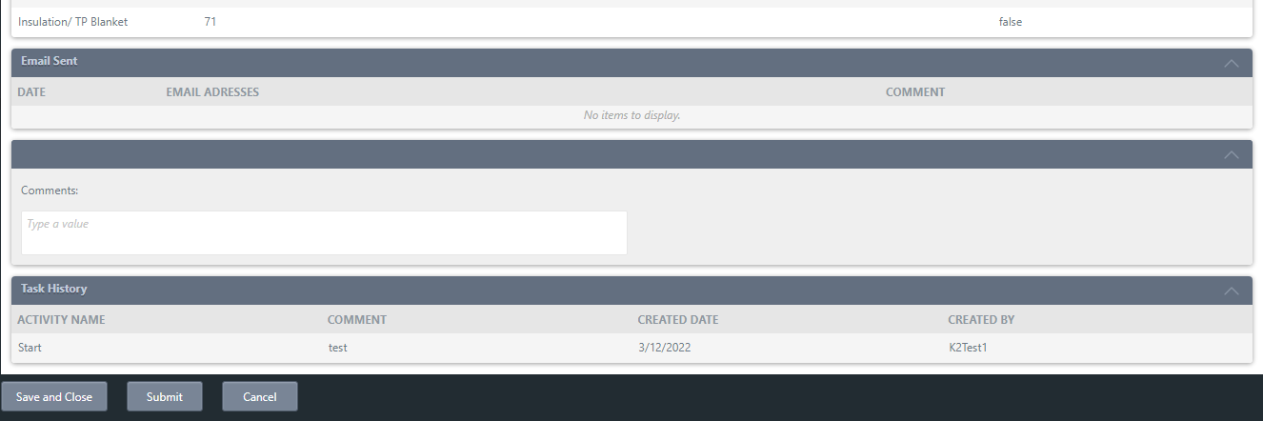

For the Plan task, the Sample Car Information block is available.

- Clicking the *Save and Close* button creates a Draft for the Sample Car request.

- Pressing the *Submit* button starts the process and saves it.

- Clicking the *Cancel* button closes the open form.

After Sample Car is completed, it will be sent to the originator and the users on the email notification tab.

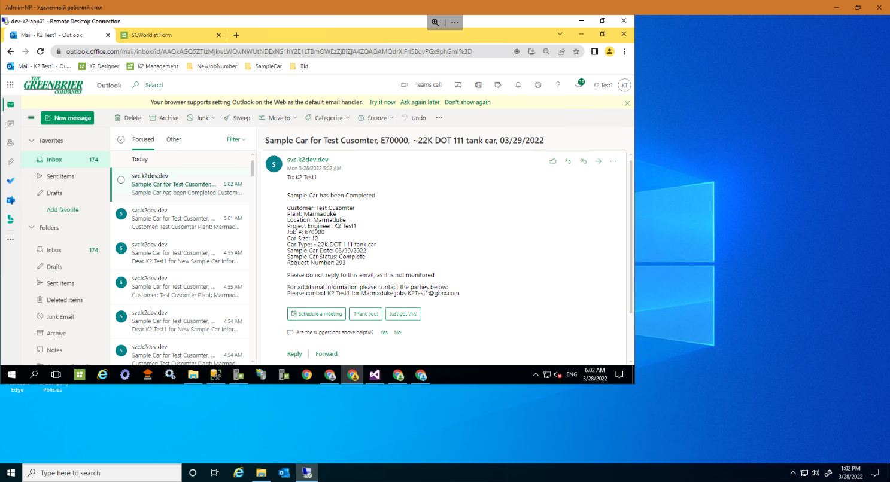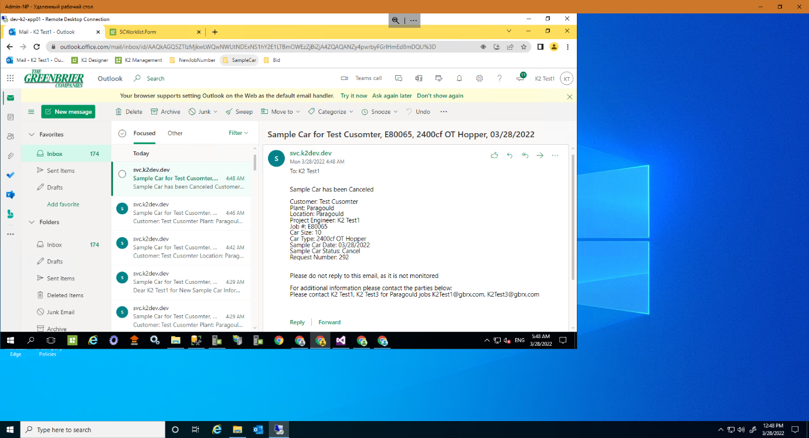

* *Commercial*

You can start working with a task by clicking on the link provided in the email or by selecting the task located directly in the worklist.

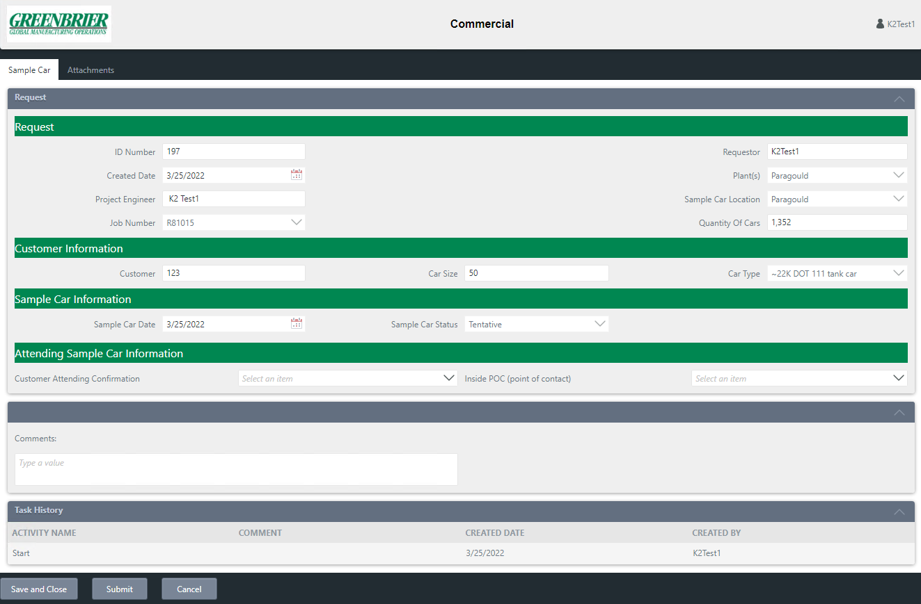

- Clicking the *Save and Close* button creates a Draft for the Sample Car request.

- Pressing the *Submit* button starts the process and saves it.

- Clicking the *Cancel* button closes the open form.

For the Commercial task, the Attending Sample Car Information block is available.

After Sample Car is completed, it will be sent to the originator and the users on the email notification tab.

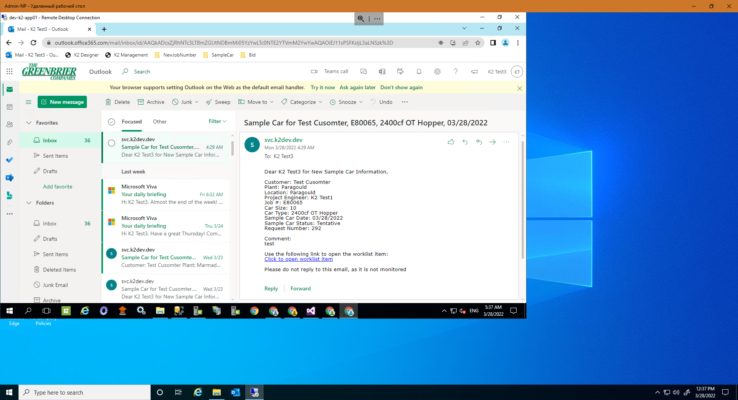

* *BIDs Group*

You can start working with a task by clicking on the link provided in the email or by selecting the task located directly in the worklist.

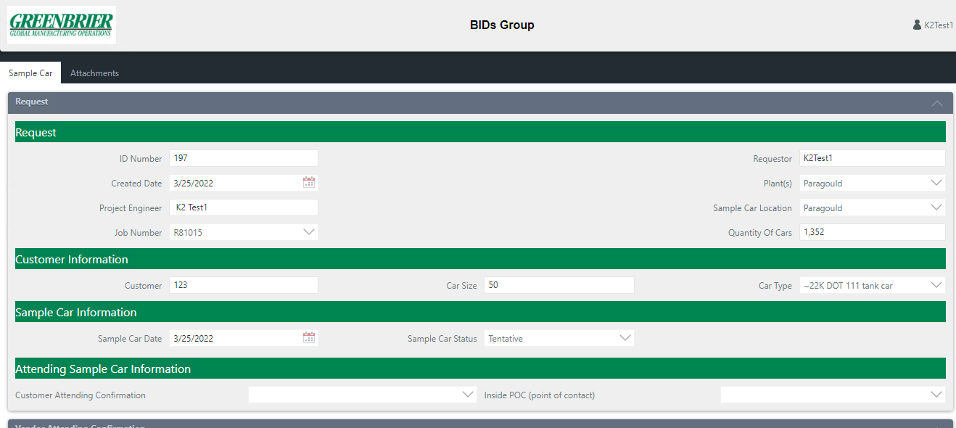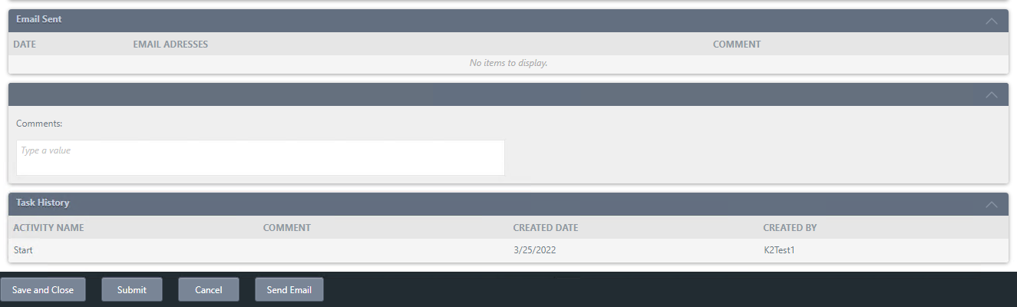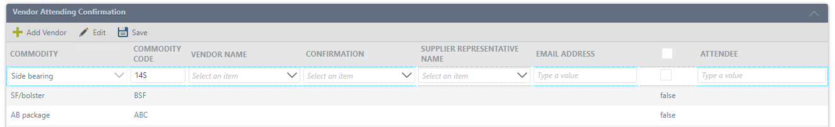

For the BIDs Group task, the block is available Vendor Attending Confirmation.

- Clicking the *Save and Close* button creates a Draft for the Sample Car request.

- Pressing the *Submit* button starts the process and saves it.

- Clicking the *Cancel* button closes the open form.

- Pressing the *Send Email* button starts the process Vendor Email Notification.

- The Vendor Attending Confirmation area has a toolbar with which you can add a Vendor to an existing list or edit an existing entry.

-After filling and editing the list, the user has the opportunity to send Emails to vendors, while the checkbox column must be set to "true."

- After clicking on the Send Email button, a list of all to whom emails have been sent will be displayed in the Sent Emails area.

This task will send two types of emails:

* Vendor Notification (from the task form), when clicked, sends an email on the bid task
* Vendor Notification will send after the bid task is completed and submitted.

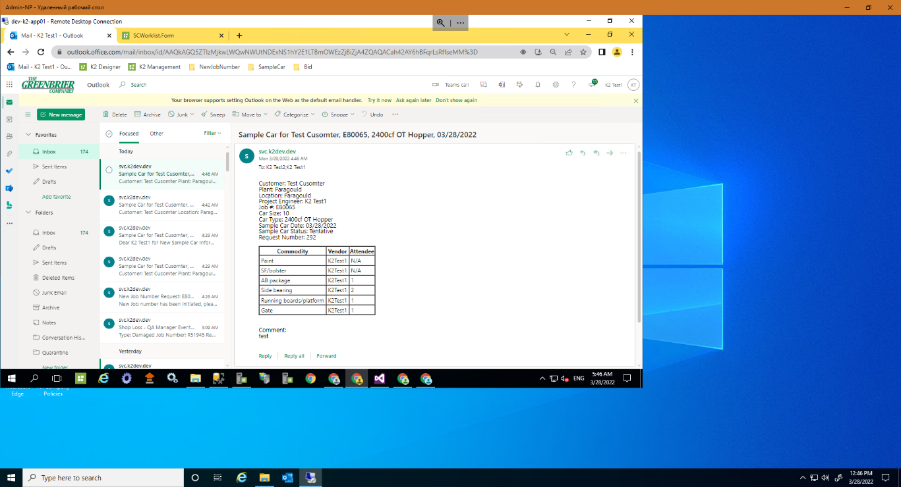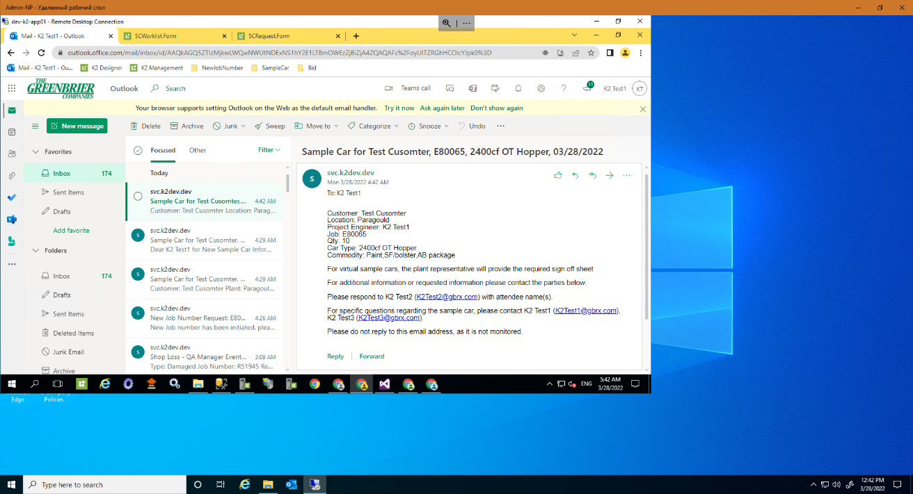

## **Worklist form - SCWorlist.Form**

Tasks are added to the worklist after the Sample Car Initiation Form has been submitted. There are no restrictions on the roles for SCWorklist.Form, there is only data filtering - everyone sees only their tasks.

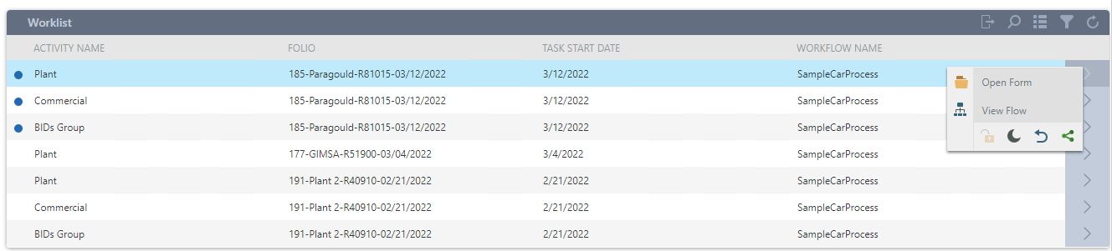

Functions available for working with the current task opening a form, viewing flow, redirect, share, etc.

*Open form* - opens the work form for the current job

*View flow* - displays the workflow for the current project, showing what stage the process is in

*Release* - returns to a group of recipients with the status of an unread (available) task

*Sleep* - allows you to be removed from the worksheet, for a certain period of time

*Redirect* - sends the execution of the current task to another user

*Share* - adds the ability to perform the current task to another user

Toolbar for easy use of the worklist form

*Refresh* - the ability to update the information provided on the current form

*Customize filter and sort* - customize the display of worklist information for the current user

*Multiselect* - allows you to mark several tasks with checkboxes

*Search* - search from the presented tasks

*Configure out of office* - make settings, when setting the value of absence in the office, to whom to redirect tasks

Newly received tasks

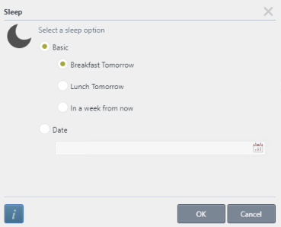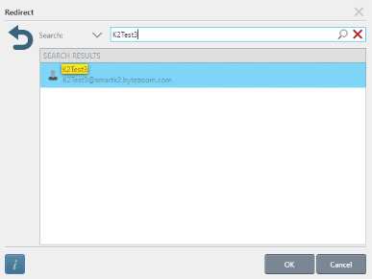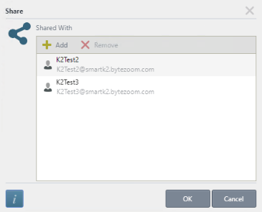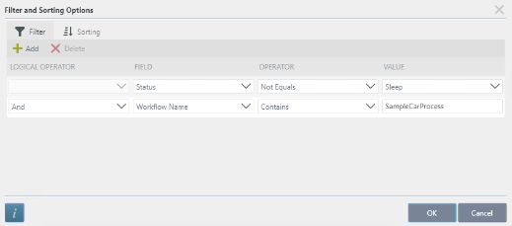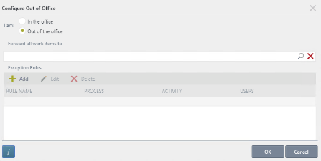

# 

# Sample Care Project and reporting data (Custom SQL Server Database)

*Tables*

***SCAdmin***

* + *[ID] [bigint] IDENTITY(1,1) NOT NULL,*
  + *[Name] [nvarchar](150) NULL,*
  + *[Type] [nvarchar](150) NULL,*

***SCAttachments***

* + *[ID] [bigint] IDENTITY(1,1) NOT NULL,*
  + *[SCRequestID_FK] [bigint] NULL,*
  + *[FileName] [nvarchar](200) NULL,*
  + *[Owner] [nvarchar](150) NULL,*
  + *[FileContent] [nvarchar](max) NULL,*
  + *[Comment] [nvarchar](max) NULL,*

***SCRequest***

* + *[ID] [bigint] IDENTITY(1,1) NOT NULL,*
  + *[ProcessInstanceID] [bigint] NULL,*
  + *[Status] [nvarchar](250) NULL,*
  + *[Requestor] [nvarchar](250) NULL,*
  + *[CreatedDate] [datetime] NULL,*
  + *[JobNumber] [int] NULL,*
  + *[Plant(s)] [nvarchar](250) NULL,*
  + *[QuantityOfCars] [int] NULL,*
  + *[Customer] [nvarchar](250) NULL,*
  + *[CarSize] [nvarchar](250) NULL,*
  + *[CarType] [int] NULL,*
  + *[OriginalSampleCarDate] [datetime] NULL,*
  + *[OriginalSampleCarStatus] [nvarchar](250) NULL,*
  + *[CustomerAttendingConfirmation] [nvarchar](250) NULL,*
  + *[UpdatedSampleCarStatus] [nvarchar](250) NULL,*
  + *[UpdatedSampleCarDate] [datetime] NULL,*
  + *[RequestNo] [nvarchar](100) NULL,*
  + *[IsSendButtonWasClicked] [bit] NULL,*
  + *[SCLocation] [bigint] NULL,*
  + *[ProjectEngiineer] [bigint] NULL,*
  + *[InsidePOC] [bigint] NULL,*
  + *[SampleCarDate] [bigint] NULL,*
  + *[SampleCarStatus] [nvarchar](100) NULL,*
  + *[ProjectEngineerDisplayName] [nvarchar](250) NULL,*

***SCSampleCarEmailNotify***

* + *[ID] [bigint] IDENTITY(1,1) NOT NULL,*
  + *[DisplayName] [nvarchar](150) NULL,*
  + *[Name] [nvarchar](150) NULL,*
  + *[Email] [nvarchar](150) NULL,*
  + *[PlantLocation] [nvarchar](150) NULL,*
  + *[UserType] [nvarchar](150) NULL,*
  + *[Gimsa] [bigint] NULL*
  + *[Gunderson] [bigint] NULL*
  + *[Plant2] [bigint] NULL*
  + *[Plant3] [bigint] NULL*
  + *[Marmaduke] [bigint] NULL*
  + *[Paragould] [bigint] NULL*

***SCTaskHistory***

* + *[ID] [bigint] IDENTITY(1,1) NOT NULL,*
  + *[SCRequestID_FK] [bigint] NULL,*
  + *[ActivityName] [nvarchar](100) NULL,*
  + *[Comment] [nvarchar](max) NULL,*
  + *[CreatedDate] [datetime] NULL,*
  + *[CreatedBy] [nvarchar](100) NULL,*
  + *[Action] [nvarchar](100) NULL,*

***SCUsers***

* + *[ID] [bigint] IDENTITY(1,1) NOT NULL,*
  + *[DisplayName] [nvarchar](150) NULL,*
  + *[Name] [nvarchar](150) NULL,*
  + *[Email] [nvarchar](150) NULL,*
  + *[Type] [nvarchar](150) NULL,*

***SCVendorConfirmation***

* + *[ID] [bigint] IDENTITY(1,1) NOT NULL,*
  + *[SCRequestID_FK] [bigint] NULL,*
  + *[Commodity] [int] NULL,*
  + *[CommodityCode] [nvarchar](150) NULL,*
  + *[VendorName] [int] NULL,*
  + *[Confirmation] [nvarchar](200) NULL,*
  + *[SupplierRepresentativeName] [int] NULL,*
  + *[Attendee] [nvarchar](200) NULL,*
  + *[EmailAddress] [nvarchar](200) NULL,*
  + *[RowStatus] [nvarchar](200) NULL,*
  + *[IsSendEmail] [bit] NULL,*

***SCVendorInfo***

* + *[ID] [bigint] IDENTITY(1,1) NOT NULL,*
  + *[VendorName] [int] NULL,*
  + *[ContactName] [nvarchar](150) NULL,*
  + *[Email] [nvarchar](150) NULL,*
  + *[PhoneNumber] [nvarchar](150) NULL,*

# DB Schema with relations

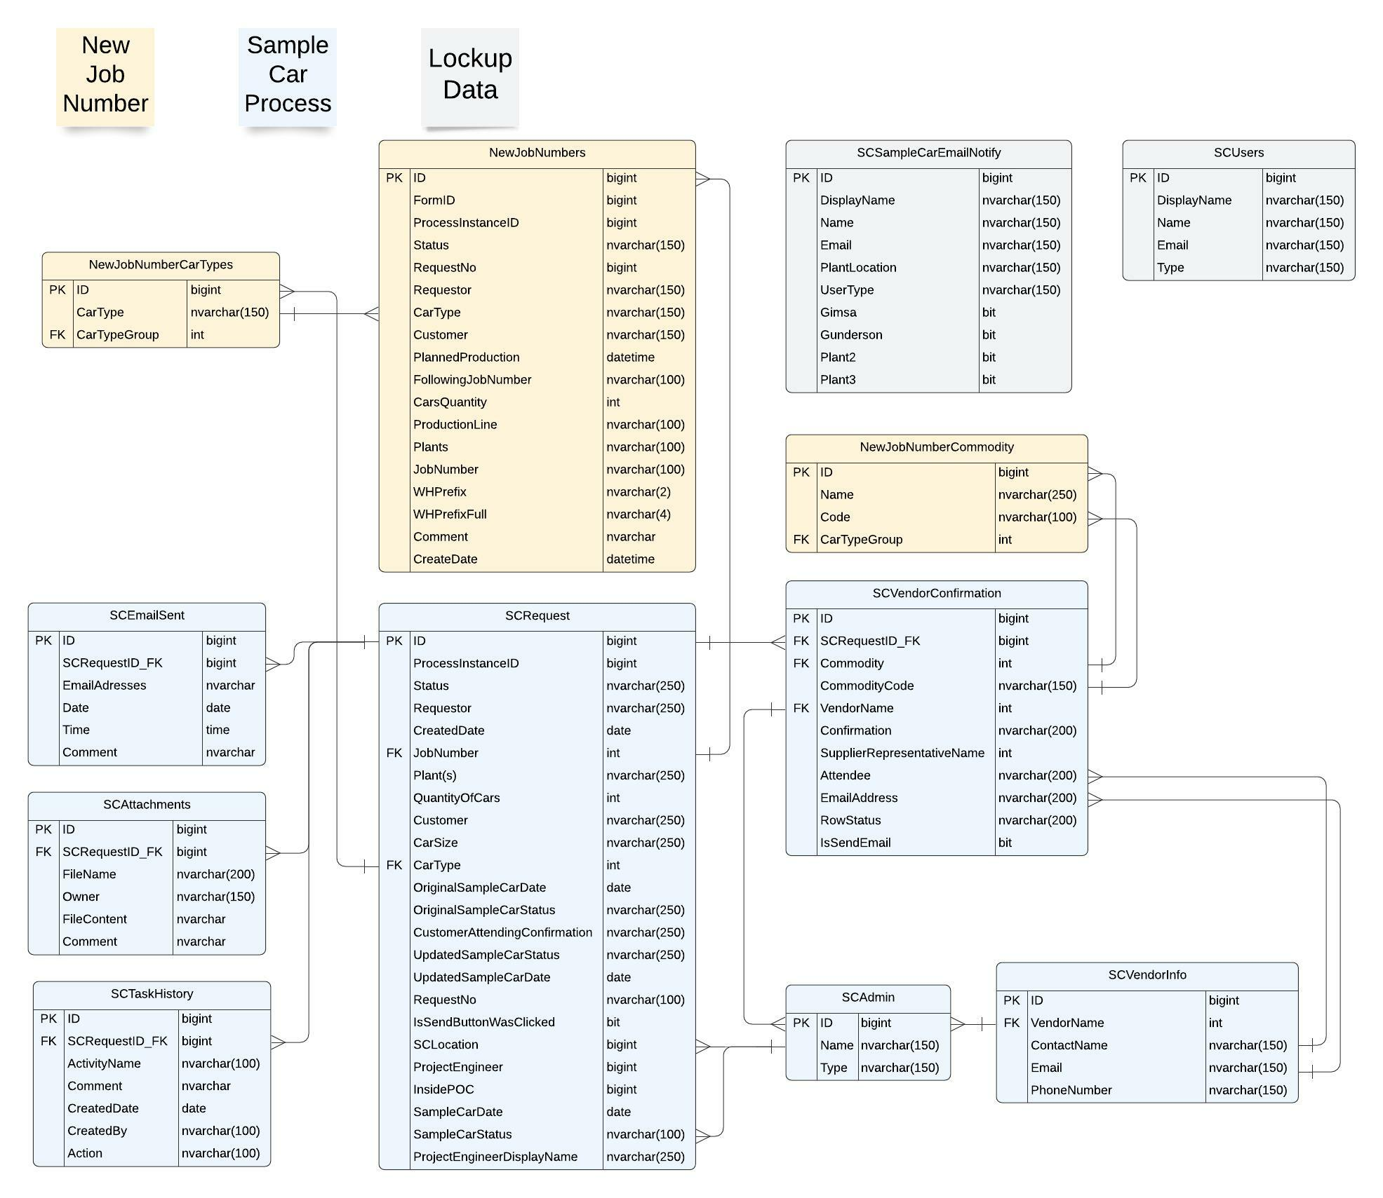

# Filtering

The user can use different filtering and quickly search for the project that they are interested in. The User can use filtering by default or configure their own filtering.

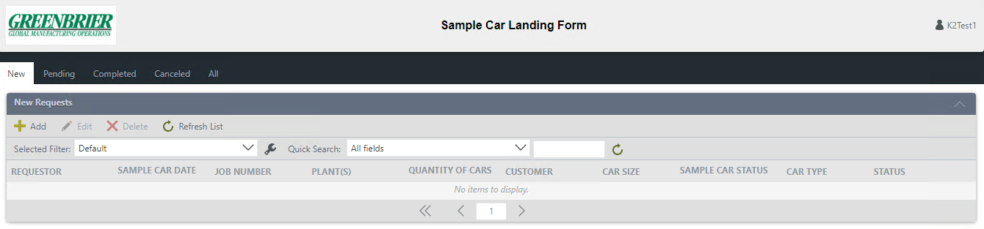

In order to customize the filter for yourself, Press the “Configure” button, after which the subordinate form “Configure User Filters” will open.

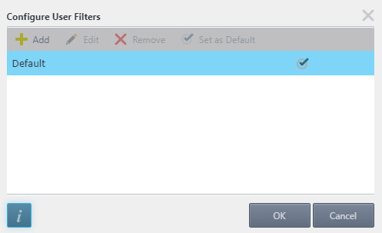



- To add a new filter, click the *“Add”* button.

- To edit a filter, select the one you need and click the *"Edit"* button.

- To remove a filter, click the *“Remove”* button.

- To use a filter every time, select the filter you want and click the *"Set as default"* button.



- The button will open the support page.

- If you want to save your changes, click the “*OK”* button in the sub form.

- By clicking on the *"Cancel"* button, you will lose all settings.

*Screen shot - Configure User Filters*

After clicking on the Add button on the Configure User Filters sub-form, a new Configure User Filters sub-form will open. There are two tabs on the Configure User Filters sub-form: Filter, Sort.

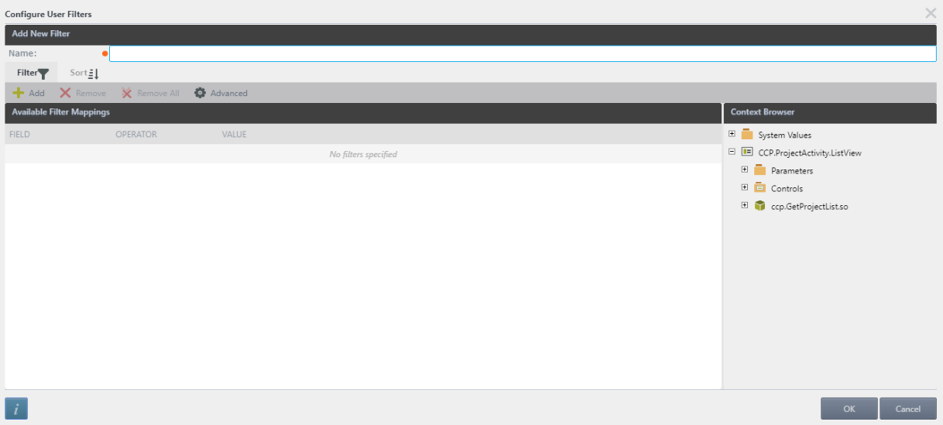

Enter the filter name and then configure filtering.

On the Filter tab



- *"Add"* button to create new rules

- *"Remove"* button to delete single selected rule

- "Remove All" button to delete all rules

- *"Advanced"* button to use more difficult filter configures.

On the Sort tab



- Click on the *“Add”* button to add sort column, select required column from the drop-down list and select sort order.

- To delete single sort rule, choose one and click on the *“Remove”* button.

- To delete all sort rules, click on the *“Remove All”* button.

- User can choose the order of sorting using *“Move up”* button to lift up the rule or *“Move down”* button to let down the rule.

*Screen shot - Configure User Filters*